Notes wrote July 16th

W3 Day 3

Programming in Cyber Security
Regular Expressions (aka RegEX or regexp) are strings of characters that define a search pattern. Also used for search and replace op.
RegEx is powerful and can be used in almost every language or OS. When using Bash or Python can use RegEx to find any needed information

Can use RegEx to find the number of instances a letter or pairing occur within a given string

May use regular expressions to extract or replace portions of text, modify text format or remove invalid characters.
RegExcheat sheet

Why Start Scripting ?
SOC (security operations center) - would ask you to program daily with different tasks, like detecting breaches, digital evidence, security traps etc. Recommended to learn one object oriented programming language.
- Python (.py)
- Shell scripting or BASH (.sh)
- BATCH (.bat)

Bash Script Example
Open terminal. Create a file with command $ nano first_ script.sh

Enter following into nano
#!/bin/bash
echo "Enter Your Name"
read name
echo "Welcome $name to the LightHouse Bootcamp"

Save with ctrl + o
Exit with ctrl + x

Change permission with chmod a+x first_script.sh

Run script with command ./first_script.sh

Shell scripting uses same commands in terminal and can provide automated scripts for all routine tasks. Like checking different log files with simple command, automating task to configure quick and easy, change permissions of users and directories at the same time.
Second Bash Example
Resource link: https://opensource.com/article/19/12/automation-bash-scripts

#!/bin/bash
echo "Enter any number"
read n
if [[ ( $n -eq 15 || $n -eq 45 ) ]];then
echo "You won the game"
else
echo "You lost the game"
fi

Regular Expression - RegEx
May use RegEx to extract or replace portions of text, modify text format, remove invalid characters. They are case sensitive.

RegEx is not a file pattern. File patterns are used in commands … rm , cp, etc…
RegEx is a line of text that returns relevant lines that contain what the RegEx line is asking for.

Types of Regular Expression
Not all programs use the same regular expressions or the same standardized types of regular expressions. Three types of RegEx and the first two are a part of what is the portable operating system interface (POSIX).
- POSIX Basic Regular Expressions (BRE)
- POSIX Extended Regular Expressions (ERE)
- Perl Regular Expressions

RegEx ABCs
the interactive tutorial about RegEx ABCs
Did till lesson 6

Quiz Bash
- Which of the following strings is not queried by the following regular expression: (B(AB|A)*D)*?
  - BAADBAABBDBAD
  - Correct. This string has a sequence of two letters B, which is excluded in the regular expression.

- Which expression would you use to locate any pattern that matches this sequence: three numbers, then a hyphen, and then three letters. For example, 111-abc
  - [0-9]{3}-[a-z]{3}
  - Correct. [0-9]{3} will return three whole numbers (0-9). Similarly, [a-z]{3} will return three letters.

- How can you append the output of a list of directory contents to a file?
  - ls >> file
  - Correct. Try the command in a Linux terminal to see what it does.

- What command is used to forward errors to a file?
  - 2> filename
  - Correct. Try the command in a Linux terminal to see what it does.

- In Shell scripting, what does $? Return?
  - $? will return the exit status of the last command. Non-zero if the command gets successfully executed, 0 if the command fails.

Hands-on Learning RegEx
cat → short for concatenate commands.
Allows you to read and view the content of a file, create single or multiple files and concatenate or redirect output to other commands in the terminal.

grep → often used to filter searches. Filtering will need to surround the RegEx with single quotes. By default grep is the basic regex, tho if you want the extended RegEx then use [-E]

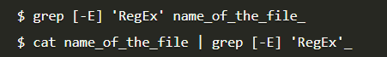

In linux, | command connects one command output to the other’s input.
To change the environment variable type the –color value. 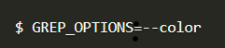

Sed and Awk
The sed command, best suited for replacing text but can also be used for searching.
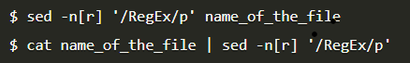 sed command uses basic RegEx but for extended regex [-r] option must follow.

awk → command used for processing, manipulating data and producing formatted reports. Used mostly for pattern scanning.

Links: Advanced Bash RegEx with Examples
Bash regexps for Beginners with Examples

AI Links
- AI Prompts for Developers
- Coding Prompts
- AI Code Tools
- using AI tools for tedious Regex tasks
- using AI to create Bash scripts

W3 Day 4
Learning Bash
Bash script support
First bash script
First function in bash
First interaction with bash scripts
Logic with Counters and loop

If and Case Statements
If and Case Statement are used in bash, but what is the difference between AND and OR.
- AND is if both of the statement are true its true and if only one then neither are true
- OR is if either one is true its true and if both are true. But if neither are true then it's false.

&& → AND || → OR

Example of Case statement code in Bash
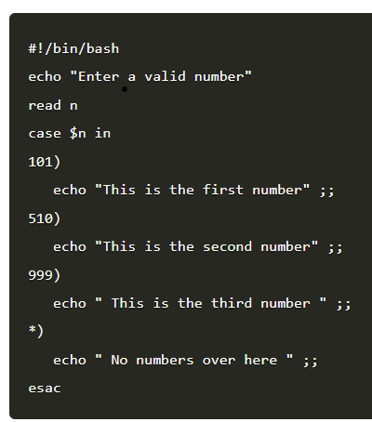
https://devhints.io/bash

Why Scripting?
Unit on Bash and Regular Expression (RegEx) to process web server as logs
- How can I use Bash scripts to automate common Cyber Security tasks?
- How do I create and use Regular Expressions (RegEx) patterns to search for specific information?
- How can I use RegEx to extract information from data for analysis?

Use of RegEx with Bash Scripts
One example of a regex is ^([a-zA-Z0-9_\-\.\+]+)@([a-zA-Z0-9_\-\.]+)\.([a-zA-Z]{2,5})$ which can be used as a text filter.
Terminal commands echo, sed, egrep, awk

- Basic Regular Expressions (BRE)
- Extended Regular Expressions (ERE)

Regular expressions are case sensitive and the engine treats space as standard characters.
Thus when matching a particular pattern the caps and spacing matters.

Metacharacters = must use a \ with the following characters to be able to search for it.

* [ ] ^ $ { } \ + ? | ( )

So to use a question mark type \?

RegEx with Bash Scripts task 2, 3, 4

WebServer Logs
First read: Best Tips for Monitoring and Filtering Your Web Server Logs

Notes from reading:
Using web server logs allows for easy identification of where a problem is coming from and real time solving. Logs are automatically made by the server and consist of files of info (errors, requests and other info).

Can create custom log management functionalities, with most major programing languages having log modules available.

Why to monitor logs?
Need to know if the website is running correctly, it's easy to have errors go unnoticed. Thus its key is to analyze the logs often. Looking at the logs means serving the clients better.

Before monitoring a website can start, you need to know what Os the server is hosted on. Linux/unix is the most common. Four types of web servers: apache, NGINX, LitSpeed, IIS.

Apache
Most popular web server, as it supports almost all OS. Can find logs on apache by navigating to these directories.
- /var/log/apache/access.log
- /var/log/apache2/access.log
- /etc/httpd/log/access_log (on MacOS X)
- /var/log/apache2/error.log

Use Tail Command
ex) log the errors on console using tail linux command
-$ sudo tail -f /var/log/apache2/error.log

Shows all errors in terminal and now able to troubleshoot the problems occurring. -f flag makes all log messages are echoed to the console.

Tail and egrep Command
tail -f /var/log/apache2/error.log | egrep -v "(.gif|.jpg|.png|.swf|.ico)"
The command filters unwanted files.

W3 Day 5
Crontab Generator link
https://crontab-generator.org/

Pdf textbooks from lhl: https://drive.google.com/drive/folders/1VbsNQg_5G-77bVezL8UTrK36WTMAoh90

W4 Day 1

Problem-solving Skills using Python

